**VPC WITH WINDOWS AMI**

1.Create a VPC

2.Create a public subnet with cidr 10.0.1.0/24

3.create a private subnert with cidr 10.0.2.0/24

->to create the bastion server

->give the name of the instance as bastionserver-9z

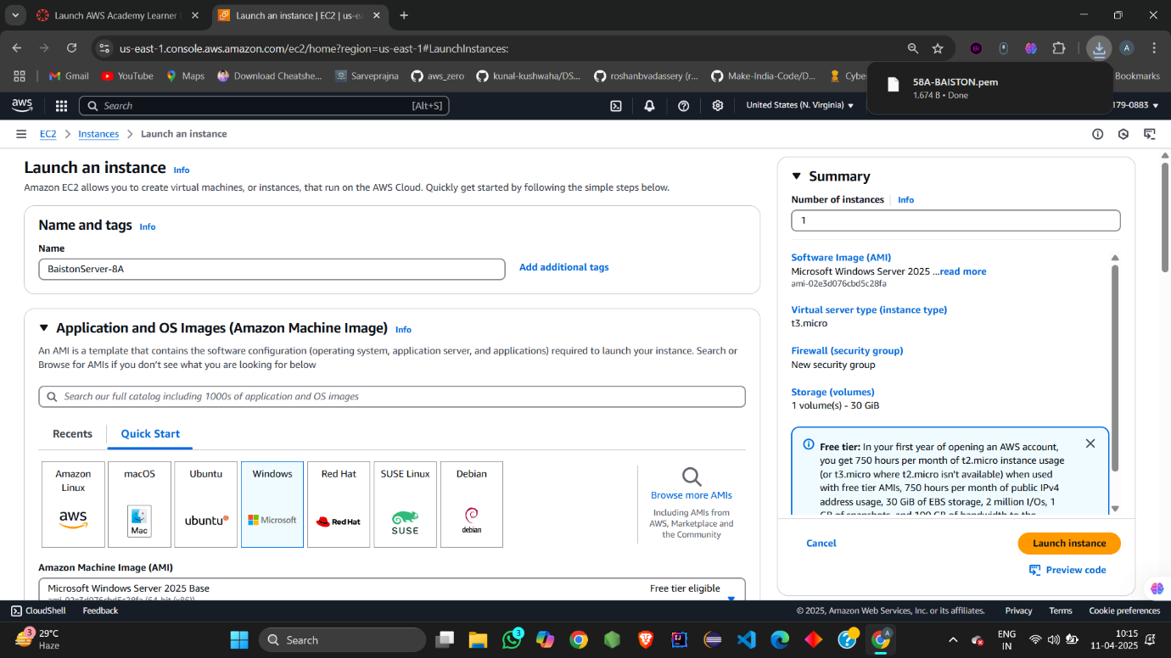

->select the ami as windows as we are working on windows

->create a pem key pair for the bastion server

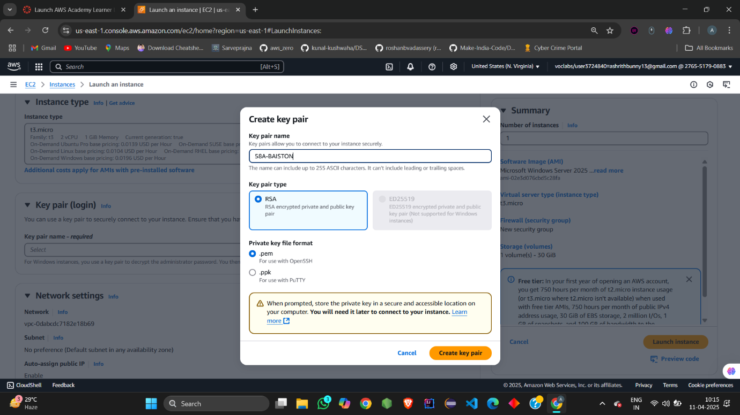

->edit the network settings and select the vpc

->choose the subnet as the webserver

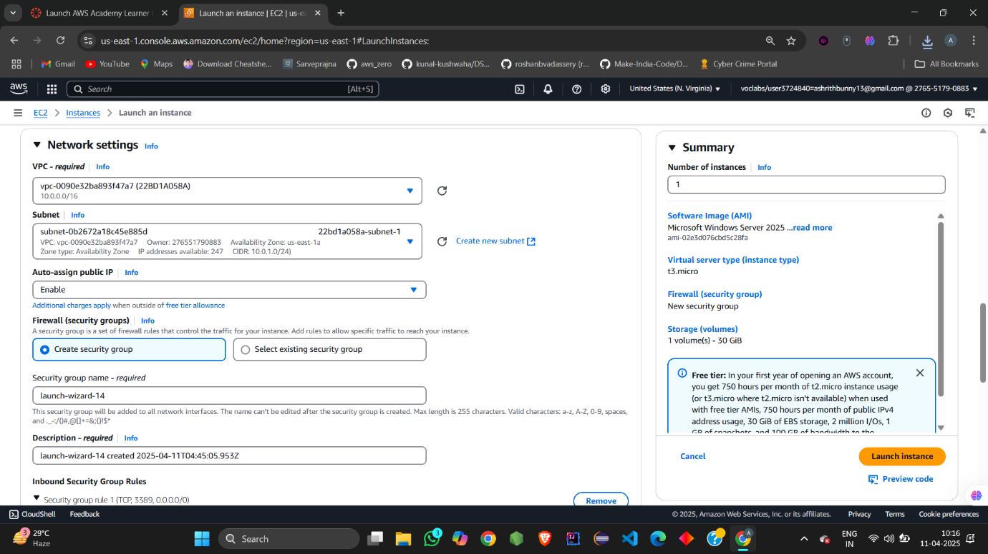

->the default type is rdp and choose the source type as myip and launch the server

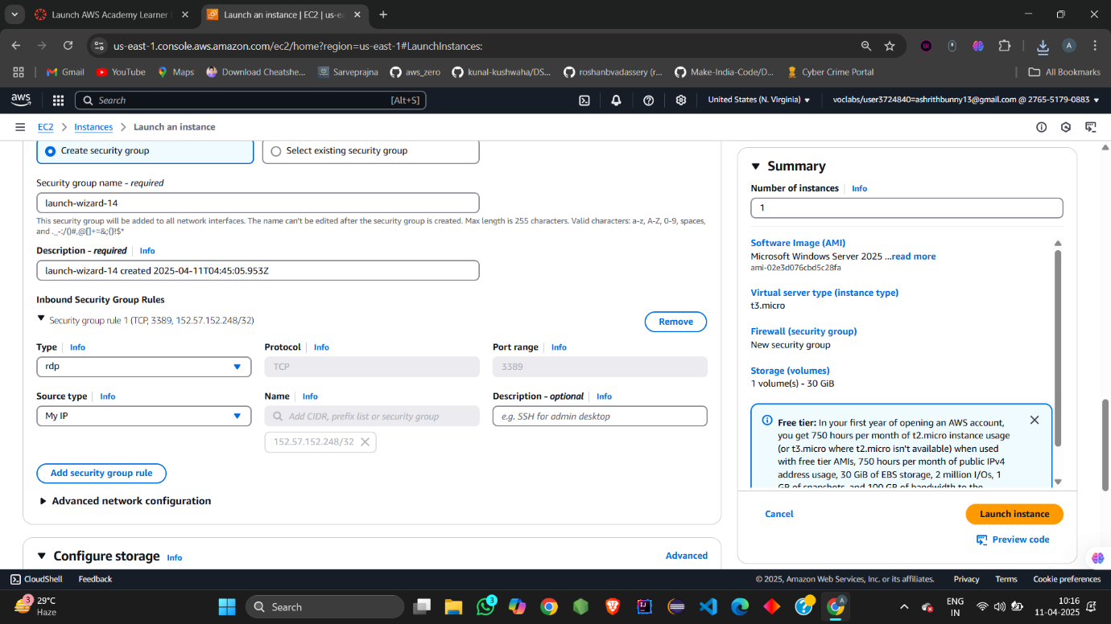

* To create the db server
* Give the name of the instance as db server and the ami as windows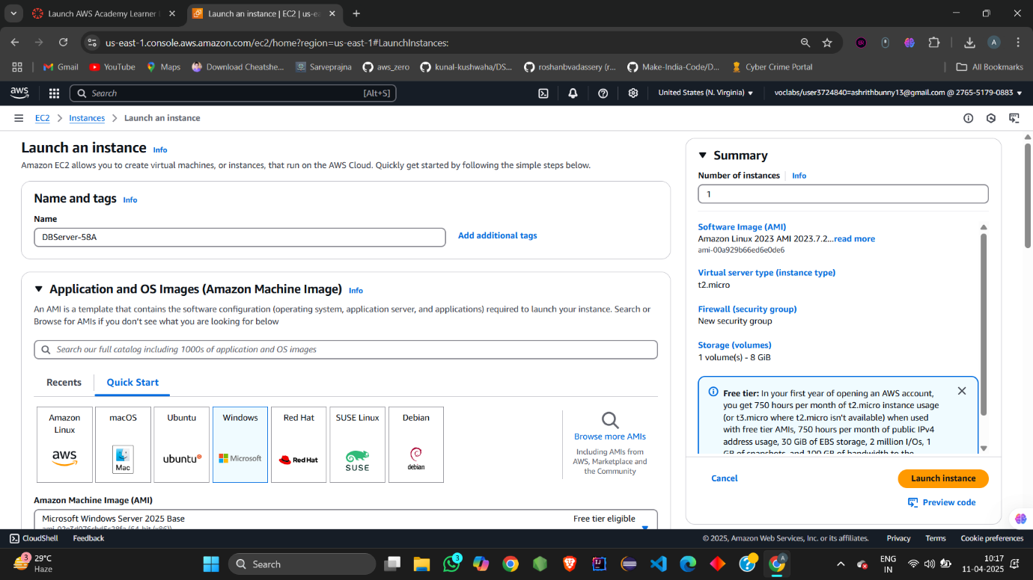
* In the network setting edit the network settings and choose the required vpc
* Select the subnet as db for db server

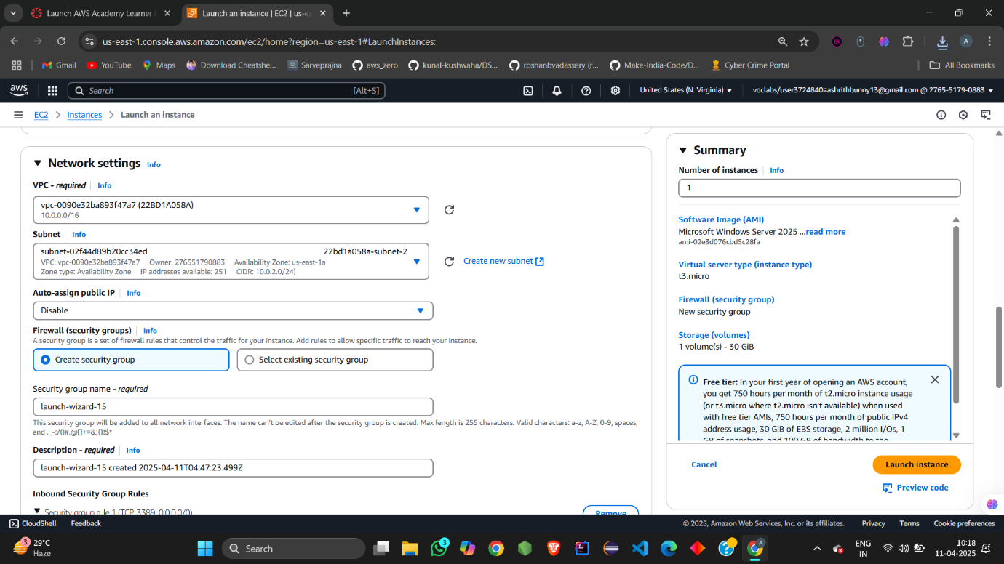

->create the pem key for the db server

-> in the network setting edit the network settings and choose the source type as custom and foe the source give the private ipv4 address of the bastion server

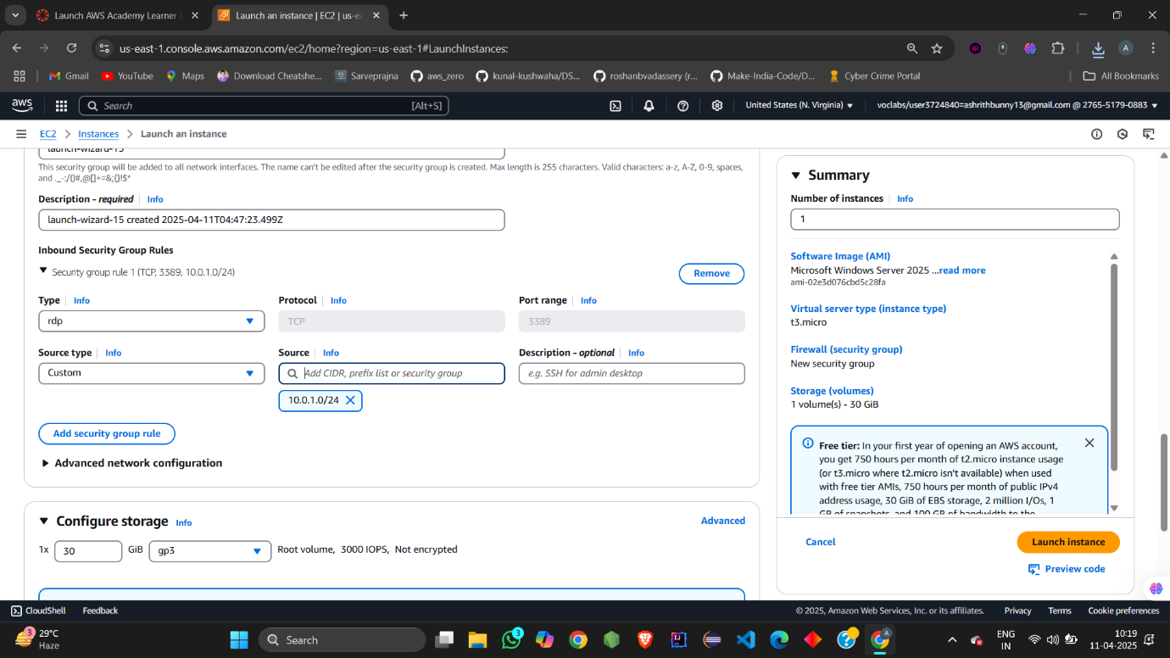

->now launch the instance

->go to the rdp client

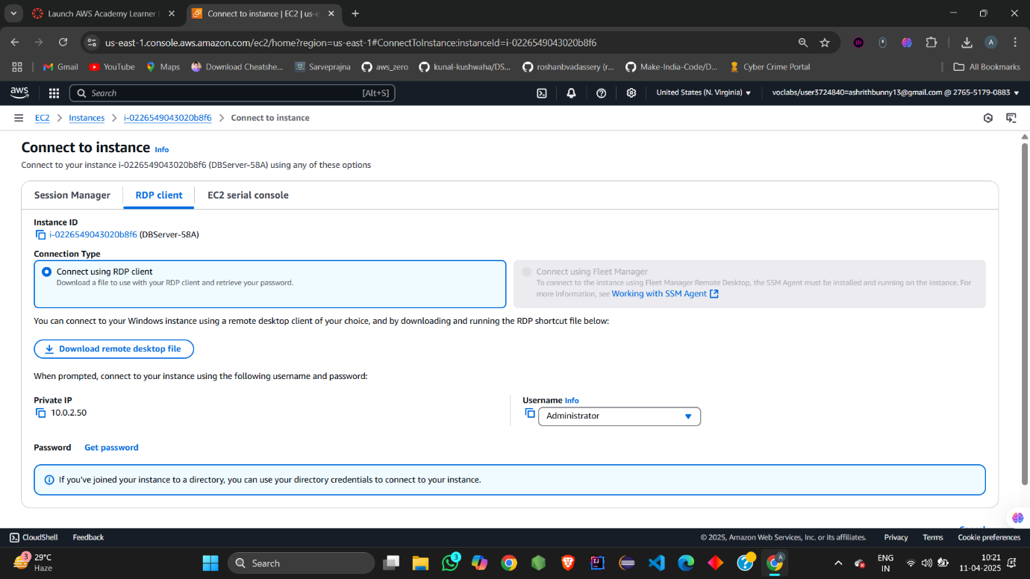

->now select the download remote desktop file 

->the remote desktop file has been downloaded



->now choose the get password option

->to get the password upload the private key of the bastion server

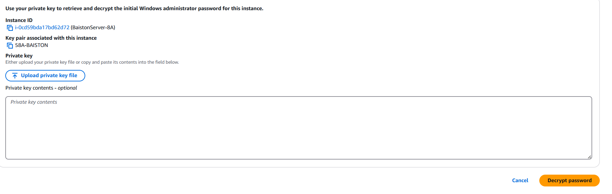

->after uploading the private key is shown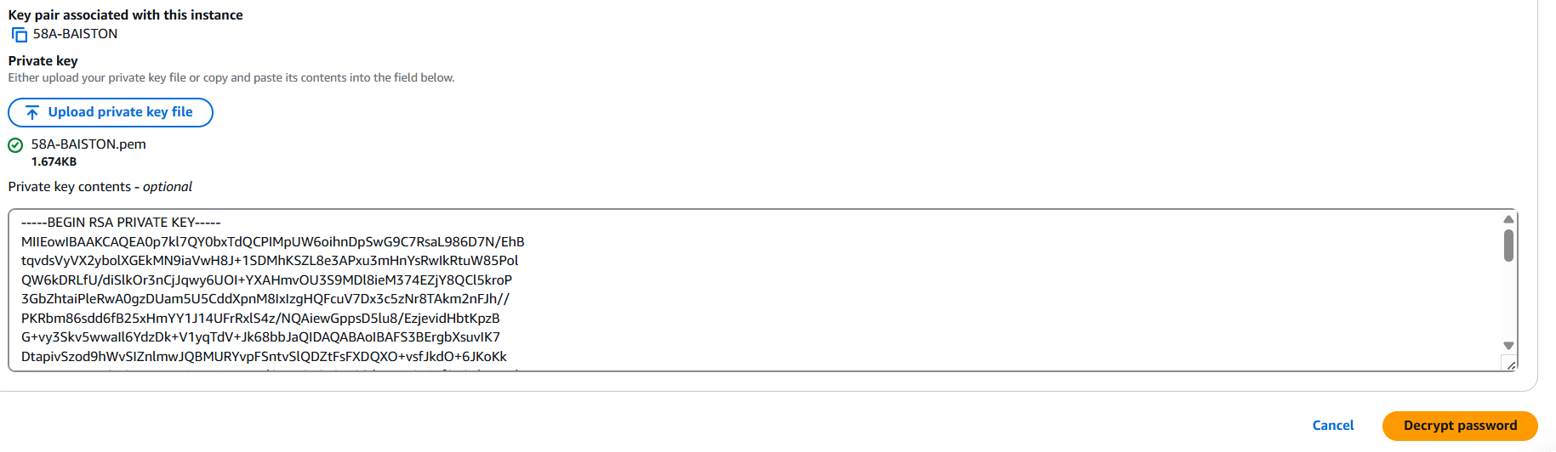

->now decrypt the password

->now copy the private ipv4 address of the db seerrver and get the password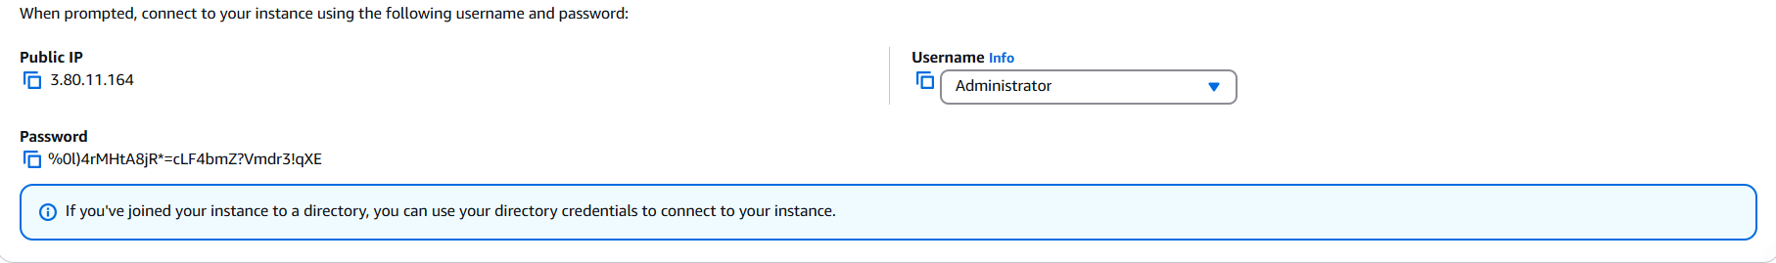

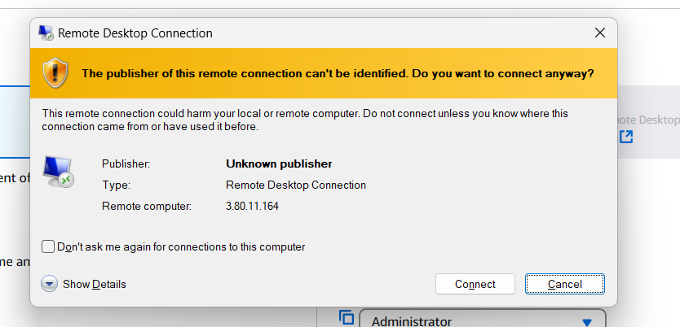

->enter the credentials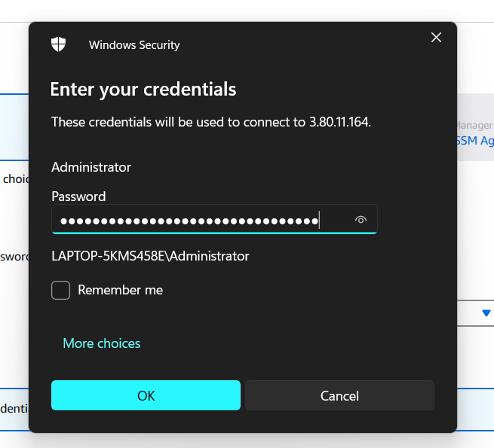

->The windows desktop opens 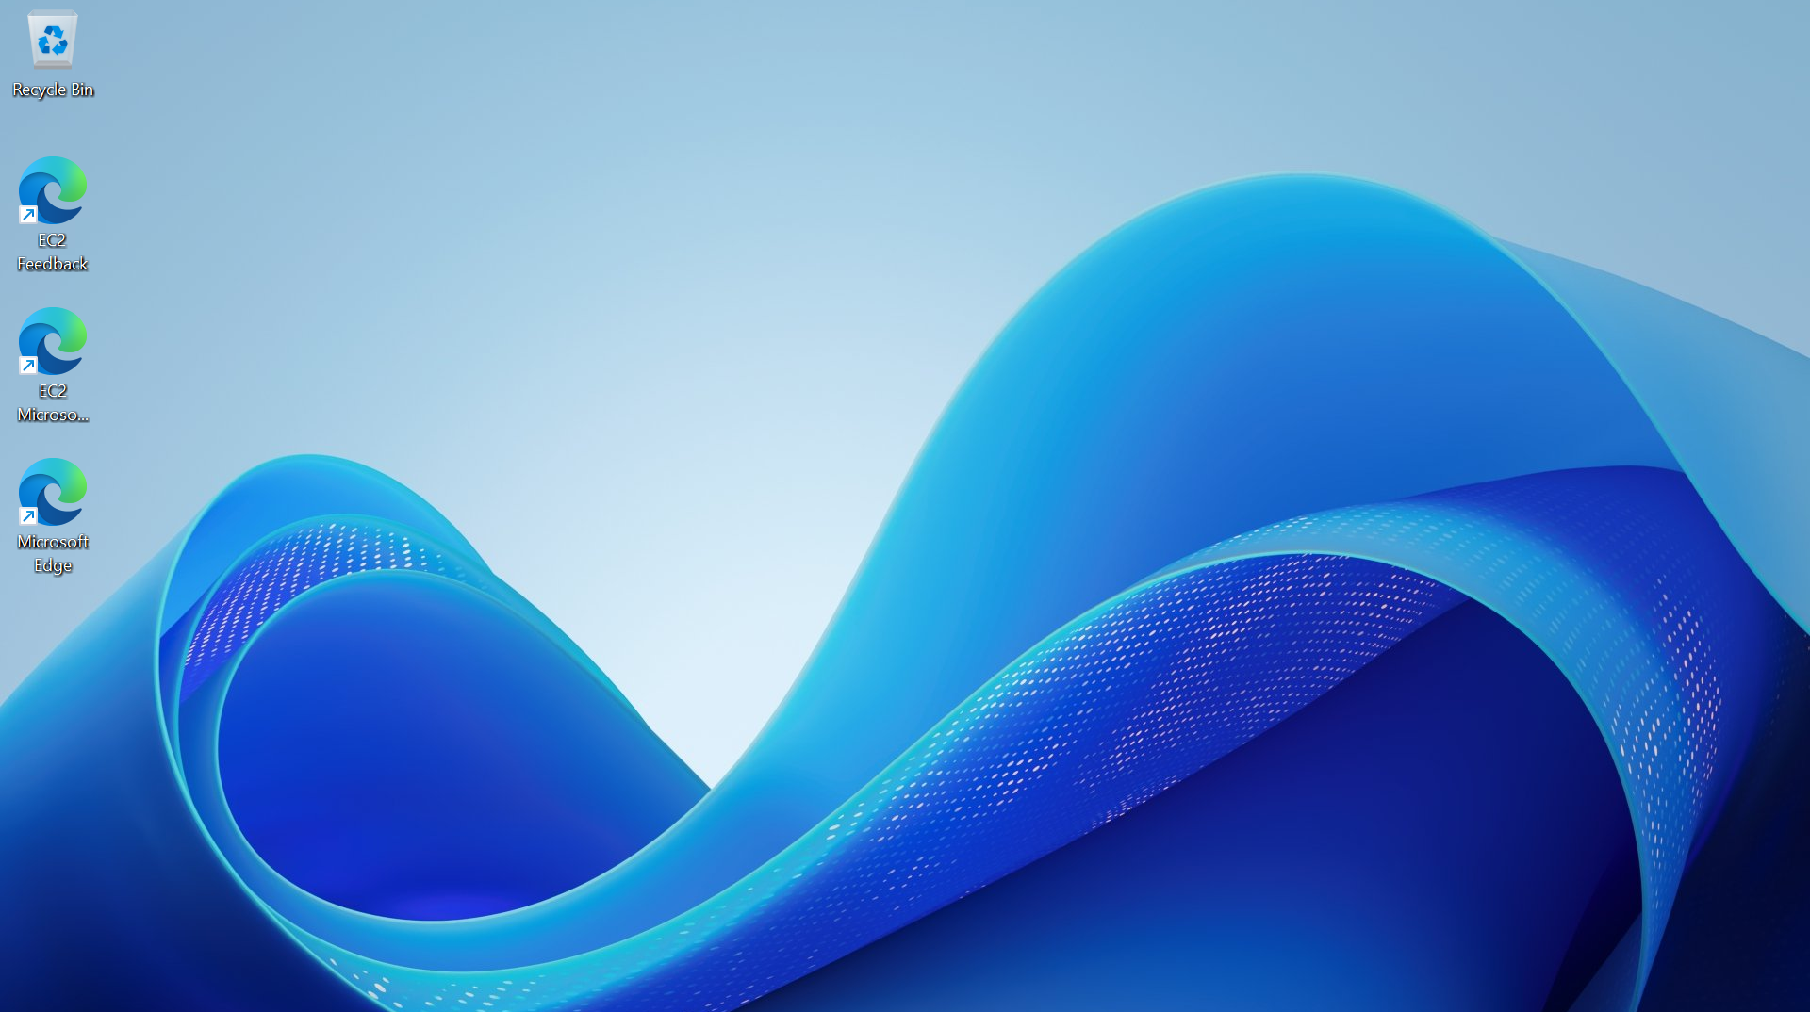

->now search for rdp in the taskbar

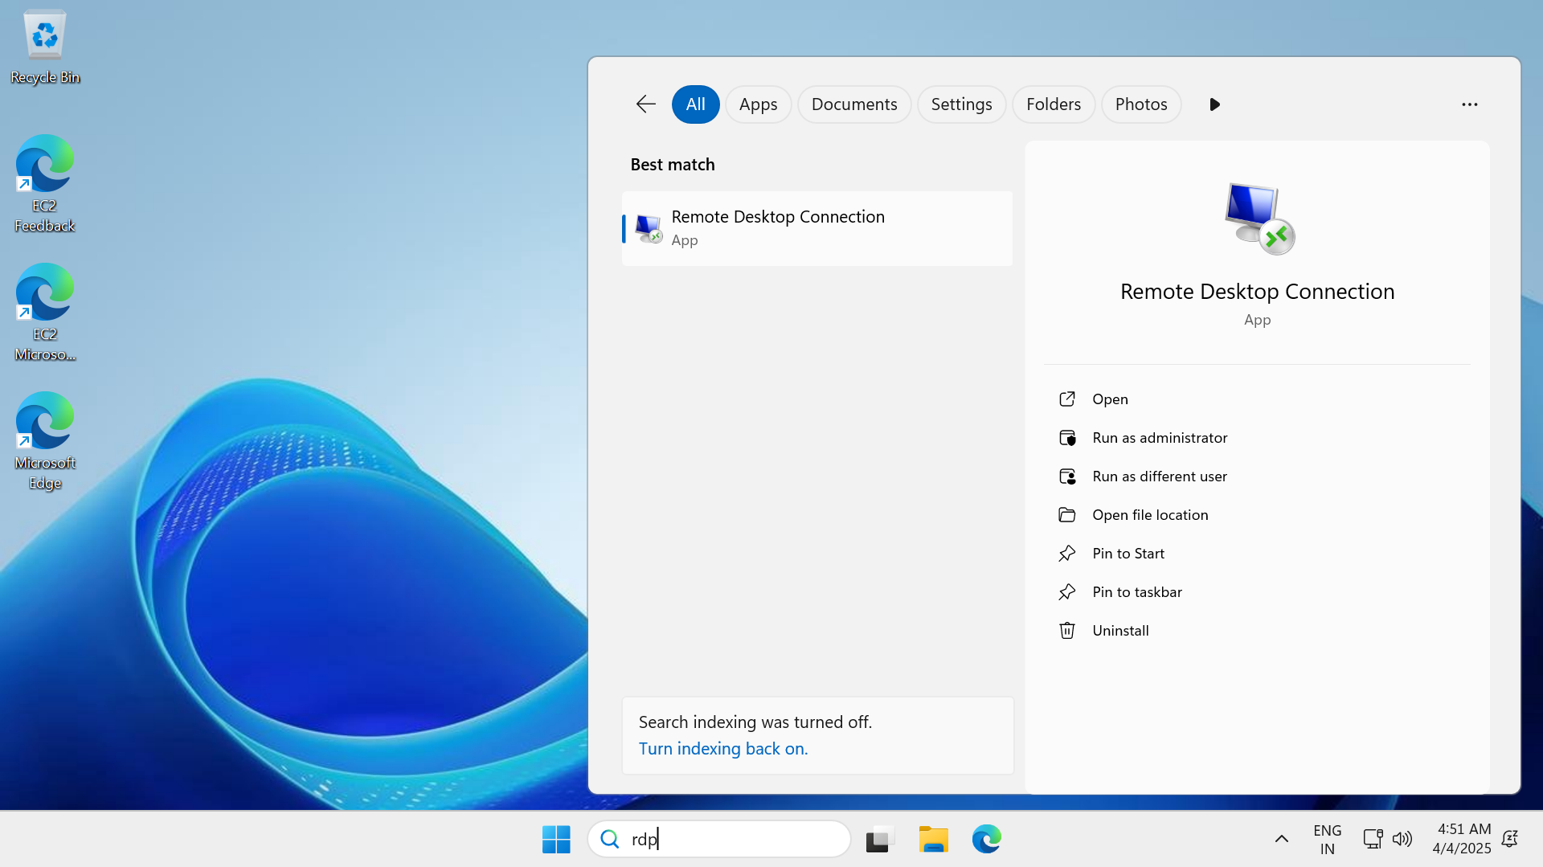

->give the private ipv4 adress of the db server and connect

* Give the password that u get from the db server

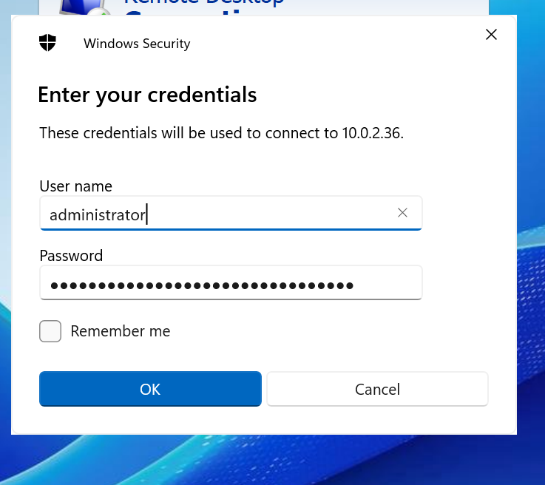

->after connecting to the db server

->now we can see that the net has been connected

->now go to miscrosoft edge and search chatgpt.com

